Inquiries from some suppliers regarding RFQ10122968 – Printing Materials and Visibility Items-BPA
نرجو منكم توضيح بعض الاصناف المذكورة في هذا الايميل لم نعرف ايش المطلوب في مناقصة المطبوعات
توضيح الاصناف التالية |  |  |  |  | يرجي الاطلاع ع الصور التوضيحية
80 | Scarf, logo | "Multicolor Style: Casual Pattern, Type: PlaidType: Scarf, Composition:100% Acrylic Material Fabric  One-size 74.8L, 12.6W  Sewing IMC logo in scarf" | EA | 300 | 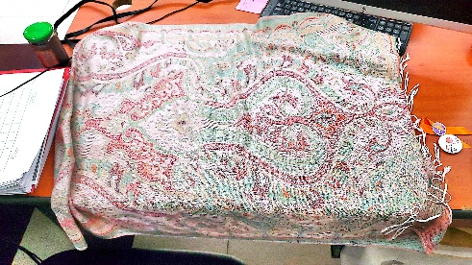
81 | Scarf, cotton | Orange and cotton scarf | EA | 90 | 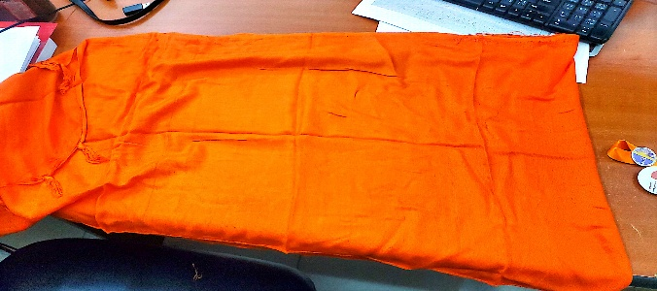
82 | Magnet, pin | Iron, circular, Glossy with 16 Days of Activism Against Gender-Based Violence logo | EA | 90 | 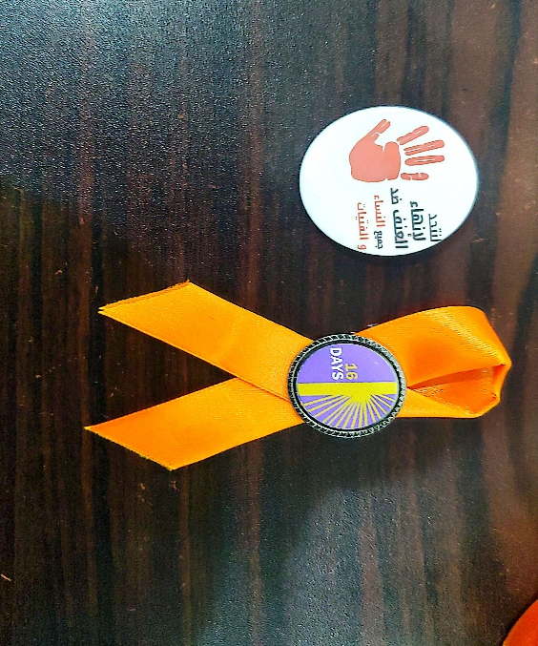  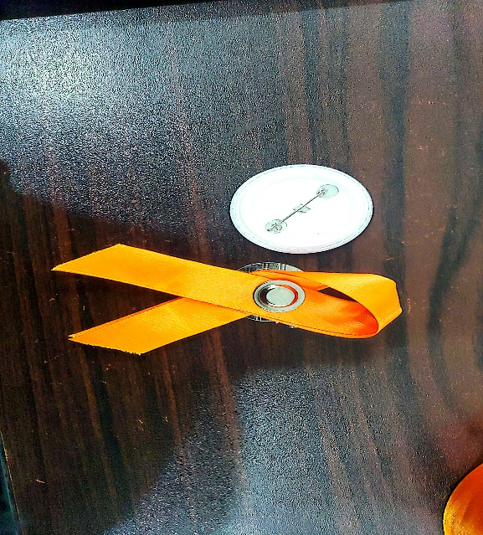
83 | Ribbon, gift wrap | big 10 Orange and 5 White 5 Blue stain ribbons | EA | 100 | 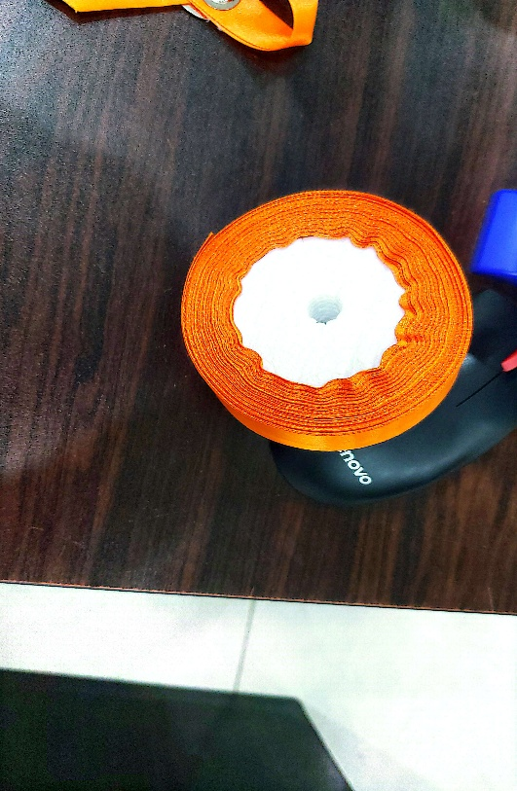

Vendor inquiries and our response highlighted in yellow color

We refer to Tender No. 10122968 regarding the Supply of Printing Materials and Visibility Items.

Kindly find below our inquiries and requests for clarification on certain tender items:

Item No. 14: Please clarify whether the notebook contains 100 pages or 400 pages per pack. 100 pages
Items No. 25–26: Please confirm whether the internal paper is colored or plain. Plain
Item No. 33: Please clarify whether one form or three forms are required. Three forms
Item No. 34: Please specify the type of boards. The type is already explained in the additional note part (Board, plastic clearly coloured and high-quality printing awareness raising marital on a plastic board heavy duty with dimension of 90*80 cm with aluminum frame ).
Items No. 35–36: Please specify the required brochure size. The type is already explained in the additional note part.
35 | Brochure, IMC, Breast Feeding | CMAM /IYCF /community midwife
36 | Brochure, IMC, Breast Feeding | Brochures on delivery and post natal care

Item No. 38: Please clarify the number of units per package for each register. 50 pages or less.
Item No. 39: Please specify the type of stand required. The type is already explained in the additional note part(" Professional aluminium-made roll up banner stand (32""X79""),Easy to assemble and convenient to travel (bag provided),Retractable base stores and protects banner graphics,Sturdy foot levellers ensure stability and safety indoors and outdoors to purchase stand with graphic((Colored) banner, during visit")
Item No. 41: The size is not specified; kindly provide the required dimensions. 1 meter*1.50 meter.
Item No. 66: Please specify the type of banner and the required stand size. The type is already explained in the additional note part(Professional aluminum roll-up banner stand (150 x 200 cm) that is easy to assemble and travel-friendly (includes carrying bag). The retractable base protects the banner graphics, while sturdy foot levellers provide stability for indoor and outdoor use)
Item No. 78: Please clarify the installation locations of the boards, whether inside Aden or outside Aden. The additional note part was update ,identification boards to display the name of the health facility, project name, donor logo(s), and implementing partner logo(s).
Boards to be fabricated from steel and mounted on 2-inch steel pipes with a height of 2 meters.
The base of the steel pipes should be securely fixed in plain concrete underground for stability.
Donor logos should be applied using phosphorescent stickers for visibility and durability.
Item No. 79: The item description is not clear; kindly provide further clarification. The type is already explained in the additional note part.( One piece Uniform " overall" (Cleaning fund/Mechanic )with (Vest safety )workers use orange colour with IMC & cleaning fund logos(sewing)printed in the front and back (size XXL ), cotton 100%)

Item No. 81: The item description is not clear; kindly provide further clarification. Orange scarf as attached photo.
