REQUEST FOR PROPOSAL (RFP)
Design, Supply, Installation, Testing and Commissioning of a Hybrid Solar PV System, AL Khokha PHCC
Employer: Médecins Sans Frontières - Operational Centre Brussels (Doctors without Borders), Refer to MSF OCB
Project: Hybrid Solar Photovoltaic PV System
RFP No.: YE101-LOG-26-001
Date: 26 July 2026
Contents
1. Introduction 1
2. Project Objective 1
3. Reference Information 1
4. Preliminary System Size (Reference Only) 2
5. Scope of Work 2
Phase 1 – Detailed Engineering Design 2
Electrical Design 2
Structural Design 3
Phase 2 – Supply 3
Phase 3 – Installation 4
Phase 4 – Testing & Commissioning 4
Phase 5 – Training 5
6. Deliverables 5
Drawings 6
BOQ 6
7. Technical Proposal Requirements 7
8. Commercial Proposal 8
9. Warranty 8
10. Standards 8
11. Proposal Evaluation 9
12. Important Note 9
13. Contacts and inquiries. 10

1. Introduction
MSF Belgium invites qualified contractors to submit proposals for the complete design, supply, installation, testing and commissioning of a Hybrid Solar Photovoltaic PV System.
The MSF OCB has conducted preliminary energy assessments and collected electrical load data. These documents will be provided as reference information only and shall not be considered as final design documents.
The successful Contractor shall be fully responsible for the complete engineering design of the proposed system.
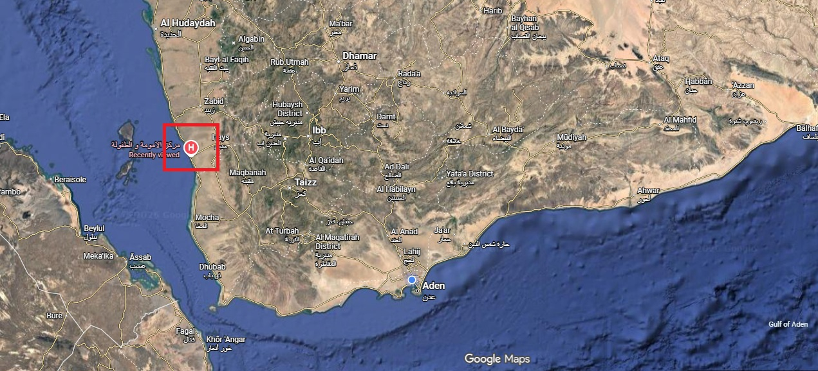
Figure 01 : AL Khokhah location overview

2. Project Objective
The objective is to design and construct a reliable hybrid solar PV system capable of reducing diesel generator operation while ensuring continuous and stable power supply to the facility.
The Contractor shall optimize the proposed solution based on the provided load profile while considering technical reliability, future expansion, ease of maintenance and life-cycle cost.

3. Reference Information
The following documents will be provided with this RFP:
- Emonio electrical load monitoring reports as per follow:
- Energy consumption from 11th of June upto 12th of July
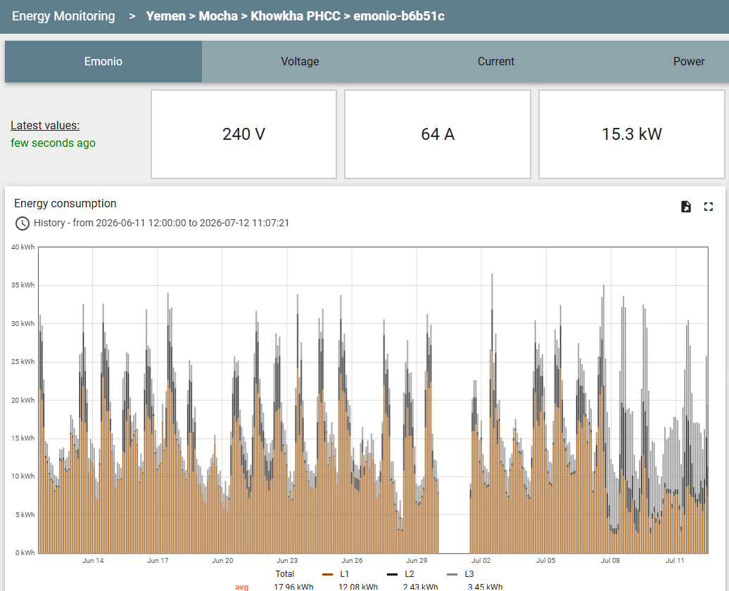
- Power profile from 11th of June to 12th of July 2026
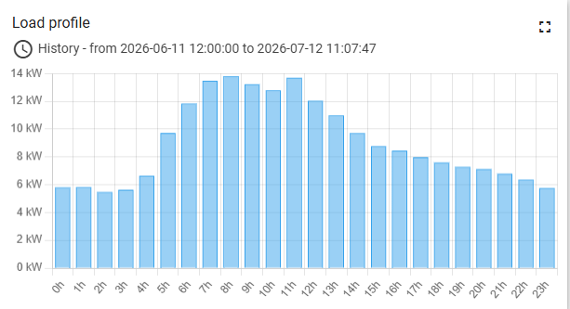

- City power energy consumption referring to the energy bill paid
City Power Energy consumption of Khowkha PHCC 2026
Febraury
DATE | Pevious merter reading in KW | Current meter reading in KW | Consumed in KWH | Unit Price | Monthly Subscription fee | Total in YERs
1/2/2026 | 0 | 1,337 | 1,337
April
DATE | Pevious merter reading in KW | Current meter reading in KW | Consumed in KWH | Unit Price | Monthly Subscription fee | Total in YERs
1/4/2026 | 4,400 | 9,487 | 5,087
June
DATE | Pevious merter reading in KW | Current meter reading in KW | Consumed in KWH | Unit Price | Monthly Subscription fee | Total in YERs
1/6/2026 | 15,657 | 22,330 | 6,673

- Inventory of electrical equipment
- Note: this is the comprehensive list of physical loads in the PHCC, not all AC’s connected for now, and probable not all planed AC’s will be connected in the future., there is already a city power and backup generator, which the planned hybrid system will be integrated into, to consider the inverter to cover all the planned loads.

- Site photo- top view
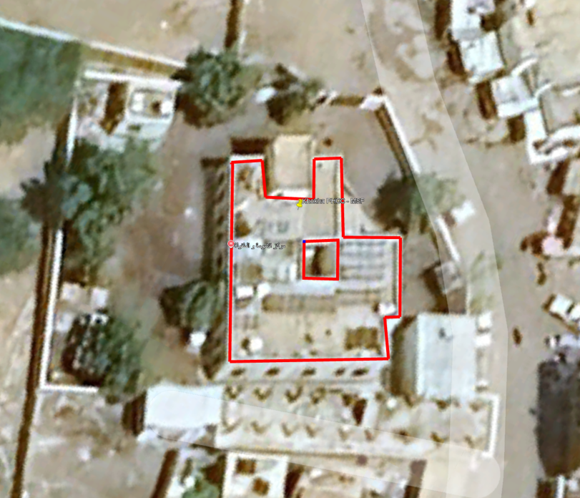
Figure02: AL khokha PHCC roofing space

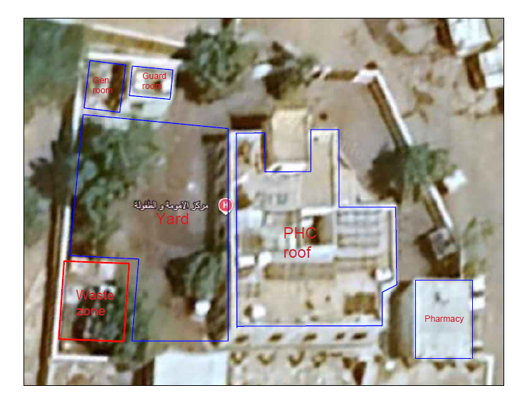
Figure 04 : roofing space available
- Existing electrical single line diagrams (not available)
These documents are intended solely to assist bidders in understanding the existing installation.
The Contractor shall verify all information during site visit.

4. Preliminary System Size (Reference Only)
The following sizing has been developed by MSF Belgium as a preliminary reference only.
Item | Reference Size | Note
Solar PV Array | 45 kWp
Battery Storage (Deye High voltage) | 60kWh
Hybrid Inverter Capacity ( Deye Highvoltage | 45-50 kW
GPS coordinates of AL Khokha PHCC | Longitude: 13.808228629228951,  latitude : 43.24711826611463
These values shall not be considered mandatory.
Bidders may propose different capacities provided they demonstrate that their proposed solution offers superior technical performance, reliability and economic justification.
Any deviation shall be fully justified through engineering calculations included within the technical proposal.

5. Scope of Work
The Contractor shall provide a complete turnkey solution including but not limited to:

Phase 1 – Detailed Engineering Design
Following contract award, the Contractor shall prepare complete engineering documentation including:

Electrical Design
- Single Line Diagram (SLD)
- Three Line Diagram where required
- Cable sizing calculations
- Voltage drop calculations
- Protection coordination study
- Earthing design
- Lightning protection design
- Battery protection design
- String design
- Inverter configuration
- Communication architecture
- Monitoring system layout

Structural Design
Complete structural calculations for:
- PV support structures
- Top Roof mounting system
- Simulation / study of the wind speed which the structural design being done according to, considering AL Khokha is a coastal area where the wind speed is very strong, that will be including but not limitred to the following:
- Wind load calculations
- Dead loads
- Live loads
- Structural stability calculations
- Anchor bolt calculations
- Foundation calculations where required
The Contractor shall provide a certified (or results of the simulation conducted) Wind Load Study used for the structural design.
The MSF OCB will not accept generic mounting calculations.
The calculations shall specifically correspond to the project location.

Phase 2 – Supply
Supply all materials including but not limited to:
- PV modules
- Hybrid inverters
- Lithium battery system
- Battery Management System (BMS)
- Combiner boxes
- DC protection
- AC protection
- Isolators
- Cables
- Cable trays
- Earthing materials
- Monitoring system
- Mounting structures
- Fasteners
- Foundations
- Labels
- Safety signage
All supplied equipment shall be new and unused.

Phase 3 – Installation
Complete installation including:
- Civil works
- Structural works
- Electrical installation
- Cable routing
- Earthing system
- Battery installation
- Commissioning preparation

Phase 4 – Testing & Commissioning
The Contractor shall perform:
- Insulation resistance tests
- Earth resistance tests
- Functional testing
- Battery testing
- PV performance verification
- Inverter testing
- Protection testing
- Synchronization testing
- Monitoring verification
- Acceptance testing

Phase 5 – Training
Provide operator training including:
- Daily operation
- Monitoring
- Preventive maintenance
- Emergency procedures (System bypassing in case of a fault in the system)
- Troubleshooting

6. Deliverables
The successful Contractor shall submit the following:
Engineering Documents
- Complete Design Report
- Design Basis
- Electrical Calculations
- Structural Calculations
- Wind Speed Study
- Cable Calculations
- Battery Calculations
- PV Simulation Report (PVsyst or equivalent)

Drawings
Minimum required drawings:
- General Arrangement
- Site Layout
- Module Layout
- Mounting Details
- Structural Drawings
- Foundation Drawings
- Single Line Diagram
- Cable Routing
- Earthing Layout
- Lightning Protection Layout
- Battery Layout
- Communication Layout
- As-Built Drawings

BOQ
Detailed BOQ including:
- Item description
- Manufacturer
- Model
- Quantity
- Unit
- Technical specifications

Technical Documentation
The Contractor shall submit catalogues and technical datasheets for every supplied component, including:
- PV Modules
- Inverters
- Batteries
- BMS
- Mounting structures
- Protection devices
- Cables
- Switchgear
- Monitoring system
- Communication equipment
- Fasteners

7. Technical Proposal Requirements
The Technical Proposal shall include:
- Company profile
- Similar completed projects
- Preliminary system concept
- Proposed system sizing
- Preliminary layout
- Technical assumptions
- Equipment manufacturers
- Construction methodology
- Project schedule
- Warranty statement
- After-sales support
Detailed engineering drawings are not required at bidding stage.

8. Commercial Proposal
The Commercial Proposal shall include:
- Itemized BOQ
- Unit prices
- Total price
- Optional items
- Delivery period
- Warranty
- Validity of proposal

9. Warranty
Minimum warranty requirements:
Item | Minimum | Note
PV Modules | 25 years performance
Product Warranty | 12 years minimum
Hybrid Inverter | 5 years
Battery | 10 years or manufacturer's standard
Structural Steel | 10 years | The location of Khokha PHCC is close to the sea, the structural elements should be resistant to such harsh environment
Installation Workmanship | 2 years

10. Standards
The proposed system shall comply with applicable international standards including:
- IEC 61215
- IEC 61730
- IEC 62109
- IEC 60364
- IEC 62548
- IEC 62446
- IEC 61683
- IEC 61724
- IEC 61439
- IEC 60529
- IEC 62305
- ISO 1461
- Eurocode (or equivalent structural standards)

11. Proposal Evaluation
Evaluation shall consider:
Criteria | Weight
Technical Compliance | 45%
Contractor Experience in solar | 15%
Design Methodology | 10%
Commercial Proposal | 25%
Warranty & After-sales Support | 5%

12. Important Note
The reference capacities provided within this RFP are preliminary estimates prepared by MSF Belgium.
Bidders are encouraged to optimize the system based on their engineering expertise.
Any proposed deviation shall be supported by appropriate technical calculations and engineering justification.
Submission of a proposal constitutes confirmation that the Contractor accepts full responsibility for the complete engineering design and performance of the installed system.

13. Contacts and inquiries.
For any inquiries please contact the following email address: MSFOCB-Yemen-Logtenders@brussels.msf.org

