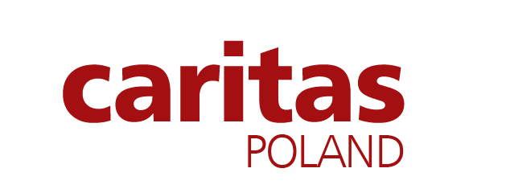
Schedule No. 28.
Current Contractual Commitments
Name & description of Contract | Contact details of Employer | Value of Outstanding Work [USD Equivalent] | Estimated Completion Date

_______________________________
Authorized signature of Company representative and Date

Please provide information on all current commitments that have been awarded or for which a letter of intent or selection has been received or for contracts approaching completion, but for which an unqualified, full completion certificate has yet to be issued.

